Chapter-2
Intel Architecture

1.0 Computer Internal Architecture

1.1 CPU Basic Operation
The Four Primary Functions of the CPU
Fetch: The basic cycle of every CPU is to fetch the first instruction from memory
Decode: decode it to determine its type and operands
Execute: execute based the opcode
Store: store the end result to the desired location
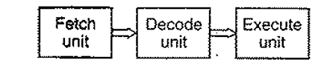
Figure 1. Instruction Cycle
The "brain" of the computer is the CPU. It fetches instructions from memory and executes them. The basic cycle of every CPU is to fetch the first instruction from memory, decode it to determine its type and operands, execute it, and then fetch, decode, and execute subsequent instructions. The cycle is repeated until the program finishes. In this way, programs are carried out

1.2 Prefetching
Prefetching is a technique for speeding up fetch operations by beginning a fetch operation whose result is expected to be needed soon. It reducing wait states and hides memory access latency.
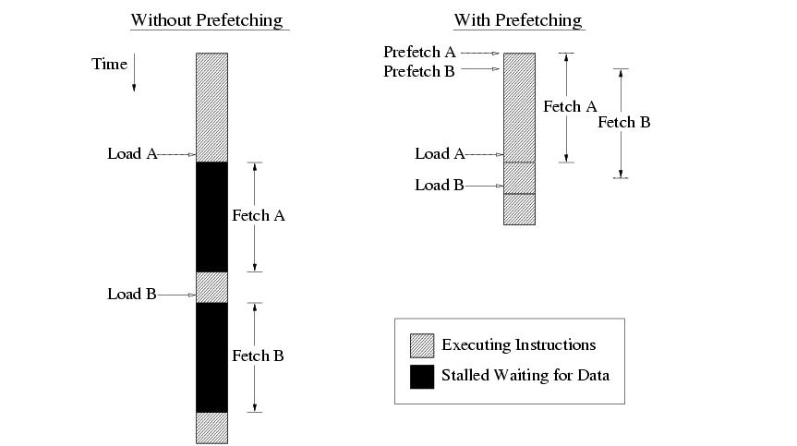
Figure 2. An example for Prefetching

1.3 Pipelining
All processors since about 1985 use pipelining to overlap the execution of instructions and improve performance. This potential overlap among instructions is called instruction-level parallelism (ILP). Pipeline is the continuous flow of instruction to the processor in an orderly manner to perform an operation. In Pipelining multiple instructions are overlapped during execution.
Pipeline is divided into stages which connected with one another to form a pipe like structure. Instructions enter from one end and exit from another end. Pipelining increases the overall instruction throughput.
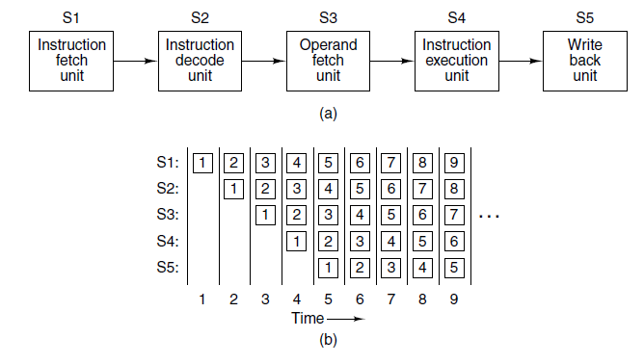
Figure 3. Pipelining

1.3.1 Types of Pipeline:

1.3.1.1 Arithmetic Pipeline:
- Arithmetic pipelines are usually found in most of the computers.
- They are used for floating point operations, multiplication of fixed point numbers etc.

1.3.1.2 Instruction Pipeline:
- A stream of instructions can be executed by overlapping fetch, decode and execute phases of an instruction cycle.
- It reads instruction from the memory while previous instructions are being executed in other segments of the pipeline.
- It increases the throughput of the computer system.

1.3.2 Advantages and disadvantages of pipeline
Advantages
- The cycle time/Machine cycle length of the processor is reduced. (Increase clock frequency)
- It increases the throughput of the system
- It makes the system reliable.
Disadvantages
- The design of pipelined processor is complex and costly to manufacture.
- The instruction latency is more.

1.4 Superscalar Architectures
It describe a processor design that issue multiple instructions—often four or six in a single clock cycle. Of course, a superscalar CPU must have multiple functional units to hand all these instructions in a single clock cycle. Superscalar processors generally have one pipeline.
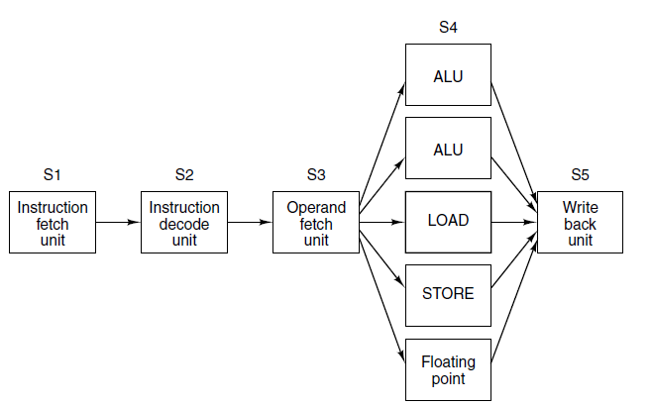
Figure 4. Superscalar architecture

1.4.1 Comparison between pipelining & superscalar
Pipelining
Divides an instruction into steps, and since each step is executed in a different part of the processor, multiple instructions can be in different "phases" each clock. In Pipelining multiple instructions are overlapped during execution. Sequencing unrelated activities such that they use different components at the same time.
Superscalar
Involves the processor being able to issue multiple instructions in a single clock with redundant facilities to execute an instruction within a single core. Multiple execution subunits able to do the same thing in parallel. Multiple sub-components capable of doing the same task simultaneously, but with the processor deciding how to do it.

1.5 Branch Prediction
Branch Predictor is a digital circuit that tries to guess which way a branch (e.g. an if-then-else structure) will go before this is known definitively. The purpose of the branch predictor is to improve the flow in the instruction pipeline because they must guess the address of the next instruction to fetch before the current instruction has been executed. allows the processor to decode instructions beyond branches to keep the instruction pipeline full. The P6 processor family implements highly optimized branch prediction algorithms to predict the direction of the instruction.
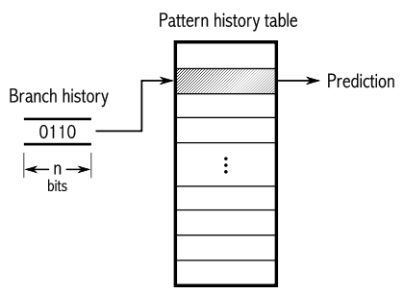
Figure 5. Branch Prediction

1.6 Out-of-order Execution
To improve the performance of the processor this can be done in two ways.
- By executing different sub-steps of sequential instructions simultaneously or even executing the instructions entirely simultaneously. Further improvement in the processor can achieved through out-of-order.
- Out-of-order execution can be achieved by executing the instruction in an different from the original order they appear.
The out-of-order execution core’s ability to execute instructions out of order is a key factor in enabling parallelism. This feature enables the processor to reorder instructions so that if one micro-op is delayed; other micro-ops may proceed around it. The processor employs several buffers to smooth the flow of micro-ops. The core is designed to facilitate parallel execution. It can dispatch up to six micro-ops per cycle (this exceeds trace cache and retirement micro-op bandwidth). Most pipelines can start executing a new micro-op every cycle, so several instructions can be in flight at a time for each pipeline. A number of arithmetic logical unit (ALU) instructions can start at two per cycle; many floating-point instructions can start once every two cycles.

1.7 Speculative Execution
Speculative execution is an optimization technique where a computer system performs some task that may not be actually needed. The main idea is to do work before it is known whether that work will be needed at all, so as to prevent a delay that would have to be incurred by doing the work after it is known whether it is needed. If it turns out the work was not needed after all, any changes made by the work are reverted and the results are ignored.
It refers to the processor’s ability to execute instructions that lie beyond a conditional branch that has not yet been resolved, and ultimately to commit the results in the order of the original instruction stream. To make speculative execution possible, the P6 processor microarchitecture decouples the dispatch and execution of instructions from the commitment of results. The processor’s out-of-order execution core uses data-flow analysis to execute all available instructions in the instruction pool and store the results in temporary registers. The retirement unit then linearly searches the instruction pool for completed instructions that no longer have data dependencies with other instructions or unresolved branch predictions. When completed instructions are found, the retirement unit commits the results of these instructions to memory and/or the IA-32 registers (the processor’s eight general-purpose registers and eight x87 FPU data registers) in the order they were originally issued and retires the instructions from the instruction pool.

1.8 P6 Family Microarchitecture
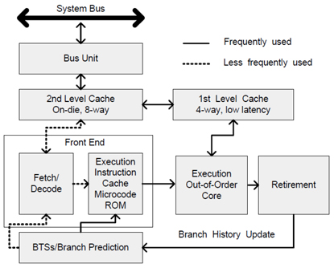
Figure 6. P6 Family Microarchitecture
- 2nd level cache, called advanced transfer cache.
- Three-way superscalar, pipelined architecture: - using parallel processing techniques, decode, dispatch and complete execution of (retire) up to three instructions per clock cycle.
- P6 processer family uses a decouples, 12- stage super-pipeline that supports out-of-order instruction execution.
- The pipeline is divided into four sections (1st level and 2nd level caches, the front end, the out-of-order execution core, and the retire section). Instructions and data are supplied to these units through the bus interface unit.

1.9 Intel NetBurst® Microarchitecture
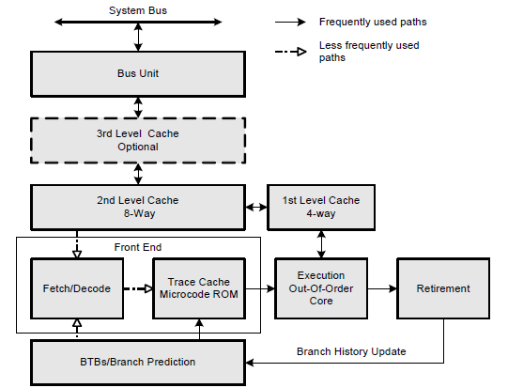
Figure 7. Intel Netburst Microarchitecture
Key features include
- The Rapid Execution Engine.
- Hyper-Pipelined Technology.
- Advanced Dynamic Execution.
- New cache subsystem.
- High-performance, quad-pumped bus interface to the Intel NetBurst microarchitecture system bus.
- Superscalar issue to enable parallelism.
- Expanded hardware registers with renaming to avoid register name space limitations.
- 64-byte cache line size (transfers data up to two lines per sector)

1.10 Intel® Core™ Microarchitecture
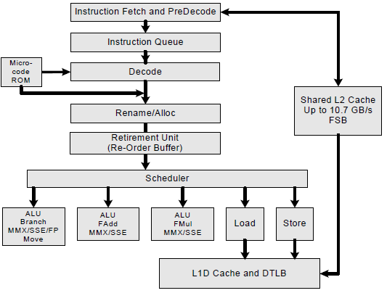
Figure 8. Intel Core Microarchitecture
Key features include
- Wide Dynamic Execution.
- Advanced Smart Cache.
- Advanced Smart Cache.
- Advanced Digital Media Boost.

1.11 Intel® Atom™ Microarchitecture
Key features include
- Advanced Micro-Ops Execution.
- Intel® Smart Cache.
- Efficient Memory Access.
- Intel® Digital Media Boost

2.0 Multiprocessors
The processing elements in an array processor are not independent CPUs, since there is only one control unit shared among all of them. Our first parallel system with multiple full-blown CPUs is the multiprocessor, a system with more than one CPU sharing a common memory, like a group of people in a room sharing a common blackboard. Since each CPU can read or write any part of memory, they must co-ordinate (in software) to avoid getting in each other’s way. When two or more CPUs have the ability to interact closely, as is the case with multiprocessors, they are said to be tightly coupled.

2.1 Multi-Core Technology
A multi-core processor is a single computing component with two or more independent processing units called cores, which read and execute program instructions. The instructions are ordinary CPU instructions (such as add, move data, and branch) but the single processor can run multiple instructions on separate cores at the same time, increasing overall speed for programs amenable to parallel computing. Manufacturers typically integrate the cores onto a single integrated circuit die (known as a chip multiprocessor or CMP) or onto multiple dies in a single chip package.

2.2 Multiprocessors v/s multithreaded v/s Multicore processors
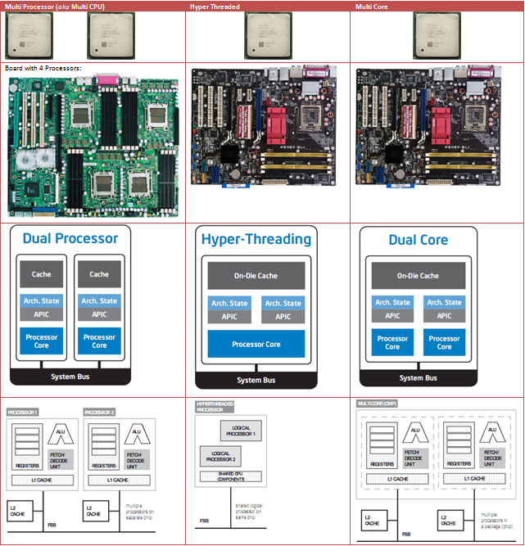
Figure 9. Difference between Dual Processor, Hyperthreading and Dual core processor
Features
- Enhanced performance
- Multiple applications
- Multiple users
- Multi-tasking inside an application
- High throughput and/or responsiveness
- Hardware sharing among CPU

2.3 Hyperthreading
Intel’s implementation of Simultaneous Multithreading (SMT). Two threads executing concurrently in one processor. Intel® Hyper-Threading Technology uses processor resources more efficiently, enabling multiple threads to run on each core. Also increases processor throughput, improving overall performance. Improve productivity by doing more without slowing down
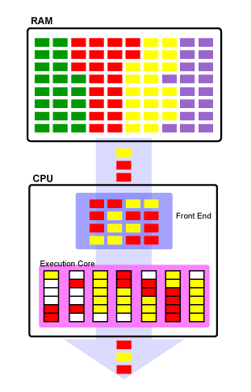
Figure 10. Single core processor with hyperthreading

3.0 Multiple Processor Initialization
A microprocessor performs a reset action for initializing the inside of the processor in response to assertion of a reset signal from the exterior upon power-on for execution of a user program, for example. The reset action includes a hardware reset action Wherein the reset signal asserted from the exterior of the microprocessor is applied to memory elements in the processor to reset the contents stored in the memory elements, and a software reset action Wherein a program for reset fetched from an external memory is executed in the processor to allow the user program to be ready for processing. Particularly, in the software reset action, When the reset signal is asserted, a reset vector entry is fetched from the external memory, and information contained in the entry is referred to, Whereby the program for reset is fetched.
IA-32 architecture defines a multiple-processor (MP) initialization protocol called the Multiprocessor Specification Version 1.4
- supports controlled booting of multiple processors without requiring dedicated system hardware.
- allows hardware to initiate the booting of a system without the need for a dedicated signal or a predefined boot processor
- allows all IA-32 processors to be booted in the same manner, including those supporting Intel Hyper- Threading Technology.
- MP initialization protocol also applies to MP systems using Intel 64 processors.
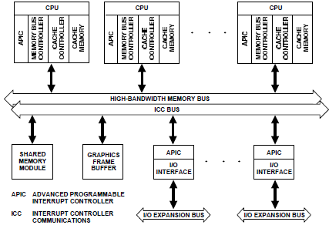
Figure 11. Relationship of Local APIC and I/O APIC

3.1 Bootstrap and Application Processors
MP initialization protocol defines two classes of processors
- bootstrap processor
- Application processors
Upon reset/Power ON system hardware dynamically selects one processor as BSP and rest as AP
Boot Strap Processor
- is responsible for initializing the system and for booting the operating system
- BSP flag is set in the IA32_APIC_BASE MSR
- executes the BIOS’s boot-strap code to configure the APIC environment
- sets up system-wide data structures
- starts and initializes the Aps
- When the BSP and APs are initialized, the BSP then begins executing the operating-system initialization code
Application Processor
- are activated only after the operating system is up and running
- the APs complete a minimal self-configuration, then wait for a startup signal (a SIPI message) from the BSP processor.
- Upon receiving a SIPI message, an AP executes the BIOS AP configuration code, which ends with the AP being placed in halt state.

3.2 Advanced Programmable Interrupt Controller (APIC)
- based on a distributed architecture in which interrupt control functions are distributed between two basic functional units, the local unit and the I/O unit.
- local and I/O units communicate through a bus called the Interrupt Controller Communications (ICC) bus
- The local APIC units also provide inter processor interrupts (IPIs), which allow any processor to interrupt any other processor or set of processors.
- Each local APIC has a Local Unit ID Register and each I/O APIC has an I/O Unit ID Register.
- The ID serves as a physical name for each APIC unit

3.3 MP Initialization Protocol Algorithm for MP Systems
- Each logical processor is assigned a unique APIC ID, based on system topology. The unique ID is a 32-bit value if the processor supports CPUID leaf 0BH, otherwise the unique ID is an 8-bit value.
- Each logical processor is assigned a unique arbitration priority based on its APIC ID.
- Each logical processor executes its internal BIST simultaneously with the other logical processors in the system.
- Upon completion of the BIST, the logical processors use a hardware-defined selection mechanism to select the BSP and the APs from the available logical processors on the system bus. The BSP selection mechanism differs depending on the family, model, and stepping IDs of the processors.
- As part of the boot-strap code, the BSP creates an ACPI table and/or an MP table and adds its initial APIC ID to these tables as appropriate.
- At the end of the boot-strap procedure, the BSP sets a processor counter to 1, then broadcasts a SIPI message to all the APs in the system. Here, the SIPI message contains a vector to the BIOS AP initialization code
- The first action of the AP initialization code is to set up a race (among the APs) to a BIOS initialization semaphore. The first AP to the semaphore begins executing the initialization code. As part of the AP initialization procedure, the AP adds its APIC ID number to the ACPI and/or MP tables as appropriate and increments the processor counter by 1. At the completion of the initialization procedure, the AP executes a CLI instruction and halts itself.
- When each of the APs has gained access to the semaphore and executed the AP initialization code, the BSP establishes a count for the number of processors connected to the system bus, completes executing the BIOS boot-strap code, and then begins executing operating-system boot-strap and start-up code.
- While the BSP is executing operating-system boot-strap and start-up code, the APs remain in the halted state. In this state they will respond only to INITs, NMIs, and SMIs. They will also respond to snoops and to assertions of the STPCLK# pin.

4.0 Basic Execution Environment
Figure 12. IA-32 Basic Execution Environment for Non-64-bit Modes
Any program running on a IA 32 processor is given a set of resources for executing instruction and for storing code, data and state information These resources make up the basic execution environment for IA 32 architecture
An Intel 64 processor supports the basic execution environment of an IA-32 processor, and a similar environment under IA-32e mode that can execute 64-bit programs (64-bit sub-mode) and 32-bit programs (compatibility submode).
The basic execution environment is used jointly by the application programs and the operating system or executive running on the processor.
• Address space — Any task or program running on an IA-32 processor can address a linear address space of up to 4 GBytes (232 bytes) and a physical address space of up to 64 GBytes (236 bytes).
• Basic program execution registers — The eight general-purpose registers, the six segment registers, the EFLAGS register, and the EIP (instruction pointer) register comprise a basic execution environment in which to execute a set of general-purpose instructions. These instructions perform basic integer arithmetic on byte, word, and double word integers, handle program flow control, operate on bit and byte strings, and address memory
• x87 FPU registers — The eight x87 FPU data registers, the x87 FPU control register, the status register, the x87 FPU instruction pointer register, the x87 FPU operand (data) pointer register, the x87 FPU tag register, and the x87 FPU opcode register provide an execution environment for operating on single-precision, double precision, and double extended-precision floating-point values, word integers, double word integers, quad word integers, and binary coded decimal (BCD) values.
• MMX registers — The eight MMX registers support execution of single-instruction, multiple-data (SIMD) operations on 64-bit packed byte, word, and double word integers.
• XMM registers — The eight XMM data registers and the MXCSR register support execution of SIMD operations on 128-bit packed single-precision and double-precision floating-point values and on 128-bit packed byte, word, double word, and quad word integers
• YMM registers — The YMM data registers support execution of 256-bit SIMD operations on 256-bit packed single-precision and double-precision floating-point values and on 256-bit packed byte, word, double word, and quad word integers.
• Bounds registers — Each of the BND0-BND3 register stores the lower and upper bounds (64 bits each) associated with the pointer to a memory buffer. They support execution of the Intel MPX instructions.
• BNDCFGU and BNDSTATUS— BNDCFGU configures user mode MPX operations on bounds checking. BNDSTATUS provides additional information on the #BR caused by an MPX operation.
Stack — To support procedure or subroutine calls and the passing of parameters between procedures or subroutines, a stack and stack management resources are included in the execution environment.

4.1 Address space
Address a linear address space of up to 4GB ($2^{32}$bytes) and a physical space address up to 64GB ($2^{36}$bytes)

4.2 Basic program execution registers

4.2.1 General-Purpose Registers
The 32-bit general-purpose registers EAX, EBX, ECX, EDX, ESI, EDI, EBP, and ESP are provided for holding the following items:
- Operands for logical and arithmetic operations
- Operands for address calculations
- Memory pointers
Although all of these registers are available for general storage of operands, results, and pointers, caution should be used when referencing the ESP register. The ESP register holds the stack pointer and as a general rule should not be used for another purpose. Many instructions assign specific registers to hold operands. For example, string instructions use the contents of the ECX, ESI, and EDI registers as operands. When using a segmented memory model, some instructions assume that pointers in certain registers are relative to specific segments. For instance, some instructions assume that a pointer in the EBX register points to a memory location in the DS segment.
- EAX Accumulator for operands and results data
Automatically used by multiplication and division instructions
- EBX Pointer to data in the DS segment
- ECX Counter for string and loop operations
- EDX I/O pointer
- ESI Pointer to data in the segment pointed to by the DS register; source pointer for string operations
- EDI Pointer to data (or destination) in the segment pointed to by the ES register;
destination pointer for string operations
- ESP Stack pointer (in the SS segment)
Used by PUSH and POP instructions, points to top of stack
- EBP Pointer to data on the stack (in the SS segment)
Used to reference parameters and local variables on the stack

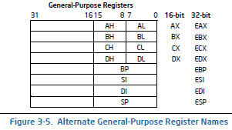

Figure 13. General Purpose Register Names
If a 64-bit operand size is specified: RAX, RBX, RCX, RDX, RDI, RSI, RBP, RSP, R8-R15 are available. REX prefixes are used to generate 64-bit operand sizes or to reference registers R8-R15.

4.2.2 Segment registers
Each of the segment registers is associated with one of three types of storage: code, data, or stack. For example, the CS register contains the segment selector for the code segment, where the instructions being executed are stored. The processor fetches instructions from the code segment, using a logical address that consists of the segment selector in the CS register and the contents of the EIP register. The EIP register contains the offset within the code segment of the next instruction to be executed. The CS register cannot be loaded explicitly by an application program. Instead, it is loaded implicitly by instructions or internal processor operations that change program control (such as, procedure calls, interrupt handling, or task switching). The DS, ES, FS, and GS registers point to four data segments.
Figure 14. Use of Segment Registers for Flat Memory Model
The availability of four data segments permits efficient and secure access to different types of data structures. For example, four separate data segments might be created: one for the data structures of the current module, another for the data exported from a higher-level module, a third for a dynamically created data structure, and a fourth for data shared with another program. To access additional data segments, the application program must load segment selectors for these segments into the DS, ES, FS, and GS registers, as needed. The SS register contains the segment selector for the stack segment, where the procedure stack is stored for the program, task, or handler currently being executed. All stack operations use the SS register to find the stack segment. Unlike the CS register, the SS register can be loaded explicitly, which permits application programs to set up multiple stacks and switch among them.
Figure 15. Use of Segment Registers in Segmented Memory Model
The four segment registers CS, DS, SS, and ES are the same as the segment registers found in the Intel 8086 and Intel 286 processors and the FS and GS registers were introduced into the IA-32 Architecture with the Intel386™ family of processors.
Segment Registers in 64-Bit Mode
In 64-bit mode: CS, DS, ES, SS are treated as if each segment base is 0, regardless of the value of the associated segment descriptor base. This creates a flat address space for code, data, and stack. FS and GS are exceptions. Both segment registers may be used as additional base registers in linear address calculations (in the addressing of local data and certain operating system data structures). Even though segmentation is generally disabled, segment register loads may cause the processor to perform segment access assists. During these activities, enabled processors will still perform most of the legacy checks on loaded values (even if the checks are not applicable in 64-bit mode). Such checks are needed because a segment register loaded in 64-bit mode may be used by an application running in compatibility mode. Limit checks for CS, DS, ES, SS, FS, and GS are disabled in 64-bit mode.

4.2.3 EFLAGS register
The 32-bit EFLAGS register contains a group of status flags, a control flag, and a group of system flags. Following initialization of the processor (either by asserting the RESET pin or the INIT pin), the state of the EFLAGS register is 00000002H. Bits 1, 3, 5, 15, and 22 through 31 of this register are reserved. Software should not use or depend on the states of any of these bits.
Some of the flags in the EFLAGS register can be modified directly, using special-purpose instructions (described in the following sections). There are no instructions that allow the whole register to be examined or modified directly.
The following instructions can be used to move groups of flags to and from the procedure stack or the EAX register: LAHF, SAHF, PUSHF, PUSHFD, POPF, and POPFD. After the contents of the EFLAGS register have been transferred to the procedure stack or EAX register, the flags can be examined and modified using the processor’s bit manipulation instructions (BT, BTS, BTR, and BTC).
When suspending a task (using the processor’s multitasking facilities), the processor automatically saves the state of the EFLAGS register in the task state segment (TSS) for the task being suspended. When binding itself to a new task, the processor loads the EFLAGS register with data from the new task’s TSS.
When a call is made to an interrupt or exception handler procedure, the processor automatically saves the state of the EFLAGS registers on the procedure stack. When an interrupt or exception is handled with a task switch, the state of the EFLAGS register is saved in the TSS for the task being suspended.
Figure 16. EFLAG Register
Status flags
- CF (bit 0) Carry flag — Set if an arithmetic operation generates a carry or a borrow out of the most significant bit of the result; cleared otherwise. indicates an overflow condition for unsigned-integer arithmetic; also used in multiple-precision arithmetic
- PF (bit 2) Parity flag — Set if the least-significant byte of the result contains an even number of 1 bit; cleared otherwise.
- AF (bit 4) Auxiliary Carry flag — Set if an arithmetic operation generates a carry or a borrow out of bit 3 of the result; cleared otherwise; used in binary-coded decimal (BCD) arithmetic.
- ZF (bit 6) Zero flag — Set if the result is zero; else cleared.
- SF (bit 7) Sign flag — Set equal to the MSB of the result, which is the sign bit of a signed integer. (0 for +ve value and 1 for -ve value.)
- OF (bit 11) Overflow flag — Set if the integer result is too large a positive number or too small a negative number (excluding the sign-bit) to fit in the destination operand; cleared otherwise; indicates an overflow condition for signed-integer (two’s complement) arithmetic.
Control flag
- DF (bit 10) Direction flag — control string instructions; if set, process string from high to low addresses (auto decrement),else vice versa
System Flags and IOPL Field
- TF (bit 8) Trap flag — Set to enable single-step mode for debugging; clear to disable single-step mode.
- IF (bit 9) Interrupt enable flag — Controls the response of the processor to maskable interrupt requests. Set to respond to maskable interrupts; cleared to inhibit maskable interrupts.
- IOPL (bits 12, 13) I/O privilege level field — Indicates the I/O privilege level of the currently running program or task. The current privilege level (CPL) of the currently running program or task must be less than or equal to the I/O privilege level to access the I/O address space.
- NT (bit 14) Nested task flag — Controls the chaining of interrupted and called tasks. Set when the current task is linked to the previously executed task; cleared when not linked.
- RF (bit 16) Resume flag — Controls the processor’s response to debug exceptions.
- VM (bit 17) Virtual-8086 mode flag — Set to enable virtual-8086 mode; clear to return to protected mode without virtual-8086 mode semantics.
- AC (bit 18) Alignment check (or access control) flag — If the AM bit is set in the CR0 register, alignment checking of user-mode data accesses is enabled if and only if this flag is 1. If the SMAP bit is set in the CR4 register, explicit supervisor-mode data accesses to user-mode pages are allowed if and only if this bit is 1.
- VIF (bit 19) Virtual interrupt flag — Virtual image of the IF flag. Used in conjunction with the VIP flag. (To use this flag and the VIP flag the virtual mode extensions are enabled by setting the VME flag in control register CR4.)
- VIP (bit 20) Virtual interrupt pending flag — Set to indicate that an interrupt is pending; clear when no interrupt is pending. (Software sets and clears this flag; the processor only reads it.) Used in conjunction with the VIF flag.
- ID (bit 21) Identification flag — The ability of a program to set or clear this flag indicates support for the CPUID instruction.

4.2.4 EIP( Instruction Pointer)
EIP contains the offset in the current code segment for the next instruction to be executed. It is advanced from one instruction boundary to the next in straight-line code or it is moved ahead or backwards by a number of instructions when executing JMP, JCC, CALL, RET, and IRET instructions. The EIP register cannot be accessed directly by software

4.3 MMX registers
8 MMX registers
support execution of single-instruction, multiple-data (SIMD) operations on 64-bit packed byte, word, and double word integers
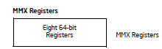
Figure 17. MMX Registers

4.4 XMM registers
8 XMM data registers
support execution of SIMD operations on 128-bit packed single-precision and double-precision floating-point values and on 128-bit packed byte, word, double word, and quad word integers
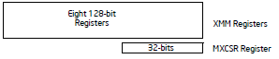
Figure 18. XMM Registers

4.5 YMM registers
support execution of 256-bit SIMD operations on 256-bit packed single-precision and double-precision floating-point values and on 256-bit packed byte, word, double word, and Quad word integers
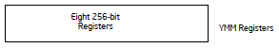
Figure 18. YMM Registers

4.6 Bounds registers
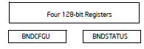
Figure 19. Bounds Registers
Each of the BND0-BND3 register stores the lower and upper bounds (64 bits each) associated with the pointer to a memory buffer. They support execution of the Intel MPX instructions.
BNDCFGU configures user mode MPX operations on bounds checking. BNDSTATUS provides additional information on the #BR caused by an MPX operation.
Other architectural features apart from Basic Execution Environment include
I/O ports
transfers of data to and from input/output (I/O) ports
Control registers
5 control registers (CR0 through CR4) determine the operating mode of the processor and the characteristics of the currently executing task
Memory management registers
The GDTR, IDTR, task register, and LDTR specify the locations of data structures used in protected mode memory management.
Debug registers
debug registers (DR0 through DR7) control and allow monitoring of the processor’s debugging operations
Memory type range registers (MTRRs)
The MTRRs are used to assign memory types to regions of memory
Machine specific registers (MSRs)
used to control and report on processor performance
Virtually all MSRs handle system related functions and are not accessible to an application program except the time-stamp counter
Machine check registers
consist of a set of control, status, and error reporting MSRs that are used to detect and report on hardware (machine) errors.
Performance monitoring counters
allow processor performance events to be monitored

5.0 Modes of operation
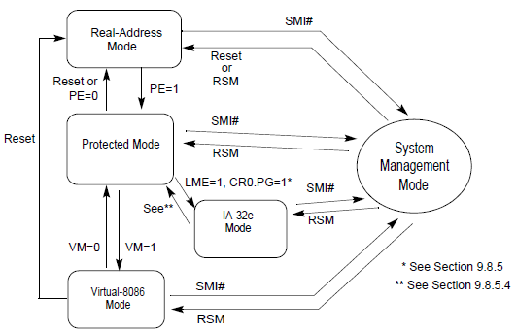
Figure 20. Transitions Among the Processor’s Operating Modes
Real-address mode. This mode implements the programming environment of the Intel 8086 processor with a few extensions (such as the ability to switch to protected or system management mode). The processor is placed in real-address mode following power-up or a reset.
Protected mode: This mode is the native state of the processor. In this mode all instructions and architectural features are available, providing the highest performance and capability. This is the recommended mode for all new applications and operating systems. Among the capabilities of protected mode is the ability to directly execute “real-address mode” 8086 software in a protected, multi-tasking environment. This feature is called virtual-8086 mode, although it is not actually a processor mode. Virtual-8086 mode is actually a protected mode attribute that can be enabled for any task.
Virtual-8086 mode
Hybrid of Protected: While in protected mode, the processor can directly execute real address mode software such as MS-DOS program in a safe multitasking environment. If an MS-DOS program crashes or attempts to write data into the system memory are, it will not affect other programming running at the same time. Each program has its own 8086 computer: Windows XP can execute multiple separate virtual-8086 sessions at the same time.
System management mode: This mode provides an operating system or executive with a transparent mechanism for implementing platform-specific functions such as power management and system security. The processor enters SMM when the external SMM interrupt pin (SMI#) is activated or an SMI is received from the advanced programmable interrupt controller (APIC). In SMM, the processor switches to a separate address space while saving the entire context of the currently running program or task. SMM-specific code may then be executed transparently. Upon returning from SMM, the processor is placed back into its state prior to the system management interrupt. SSM was introduced with the Intel386 TM SL and Intel486TM SL processors and became a standard IA-32 feature with the Pentium processor family.
Intel 64 adds IA-32e mode with 2 sub modes
Compatibility mode (sub-mode of IA-32e mode) — Compatibility mode permits most legacy 16-bit and 32-bit applications to run without re compilation under a 64-bit operating system. For brevity, the compatibility sub-mode is referred to as compatibility mode in IA-32 architecture. The execution environment of compatibility mode is the same as described in Section 3.2. Compatibility mode also supports all of the privilege levels that are supported in 64-bit and protected modes. Legacy applications that run in Virtual 8086 mode or use hardware task management will not work in this mode.
Compatibility mode is enabled by the operating system (OS) on a code segment basis. This means that a single 64-bit OS can support 64-bit applications running in 64-bit mode and support legacy 32-bit applications (not recompiled for 64-bits) running in compatibility mode.
Compatibility mode is similar to 32-bit protected mode. Applications access only the first 4 G Byte of linear address space. Compatibility mode uses 16-bit and 32-bit address and operand sizes. Like protected mode, this mode allows applications to access physical memory greater than 4 GByte using PAE (Physical Address Extensions).
64-bitmode (sub-mode of IA-32e mode) —— This mode enables a 64-bit operating system to run applications written to access 64-bit linear address space. For brevity, the 64-bit sub-mode is referred to as 64-bit mode in IA-32 architecture. 64-bit mode extends the number of general purpose registers and SIMD extension registers from 8 to 16. General purpose registers are widened to 64 bits. The mode also introduces a new opcode prefix (REX) to access the register extensions. See Section 3.2.1 for a detailed description.
64-bit mode is enabled by the operating system on a code-segment basis. Its default address size is 64 bits and its default operand size is 32 bits. The default operand size can be overridden on an instruction-by instruction basis using a REX opcode prefix in conjunction with an operand size override prefix.
REX prefixes allow a 64-bit operand to be specified when operating in 64-bit mode. By using this mechanism, many existing instructions have been promoted to allow the use of 64-bit registers and 64-bit addresses

5.1 Memory models
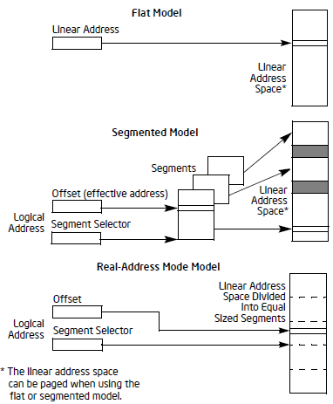
Figure 21. Three Memory Management Models
Flat memory model — Memory appears to a program as a single, continuous address space (Figure 3-3). This space is called a linear address space. Code, data, and stacks are all contained in this address space. Linear address space is byte addressable, with addresses running contiguously from 0 to 2^(32-1) (if not in 64-bit mode). An address for any byte in linear address space is called a linear address.
Segmented memory model — Memory appears to a program as a group of independent address spaces called segments. Code, data, and stacks are typically contained in separate segments. To address a byte in a segment, a program issues a logical address. This consists of a segment selector and an offset (logical addresses are often referred to as far pointers). The segment selector identifies the segment to be accessed and the offset identifies a byte in the address space of the segment. Programs running on an IA-32 processor can address up to 16,383 segments of different sizes and types, and each segment can be as large as 232 bytes. Internally, all the segments that are defined for a system are mapped into the processor’s linear address space. To access a memory location, the processor thus translates each logical address into a linear address. This translation is transparent to the application -program.
The primary reason for using segmented memory is to increase the reliability of programs and systems. For example, placing a program’s stack in a separate segment prevents the stack from growing into the code or data space and overwriting instructions or data, respectively.
Real-address mode memory model — This is the memory model for the Intel 8086 processor. It is supported to provide compatibility with existing programs written to run on the Intel 8086 processor. The real address mode uses a specific implementation of segmented memory in which the linear address space for the program and the operating system/executive consists of an array of segments of up to 64 KBytes in size each. The maximum size of the linear address space in real-address mode is 220 bytes.
With the flat or the segmented memory model, linear address space is mapped into the processor’s physical address space either directly or through paging. When using direct mapping (paging disabled), each linear address has a one-to-one correspondence with a physical address. Linear addresses are sent out on the processor’s address lines without translation. When using the IA-32 architecture’s paging mechanism (paging enabled), linear address space is divided into pages which are mapped to virtual memory. The pages of virtual memory are then mapped as needed into physical memory. When an operating system or executive uses paging, the paging mechanism is transparent to an application program. All that the application sees is linear address space.

5.2 Modes of Operation vs. Memory Model
Protected mode- any model
- Can use any model,virtual-8086 mode generally uses real addressing mode memory model
- Model used depends on the design of the OS
- In multitasking, individual tasks can use different models
Real address mode
- Only supports real address memory model
- System management mode
- Processor switches to separate address space (system management RAM)
- The memory model used to address bytes in this address space is similar to the real-address mode model
Compatibility mode
- The effect of segmentation is the same as it is in 32-bit protected mode semantics.
64-bit mode
- Segmentation is generally disabled
- Segmented and real address mode are not available in 64 bit mode

6.0 Memory Management

6.1 Basic Flat Model
Figure 22. Basic Flat Model
The simplest memory model for a system is the basic “flat model,” in which the operating system and application programs have access to a continuous, unsegmented address space. To the greatest extent possible, this basic flat model hides the segmentation mechanism of the architecture from both the system designer and the application programmer.
To implement a basic flat memory model with the IA-32 architecture, at least two segment descriptors must be created, one for referencing a code segment and one for referencing a data segment. Both of these segments, however, are mapped to the entire linear address space: that is, both segment descriptors have the same base address value of 0 and the same segment limit of 4 GBytes. By setting the segment limit to 4 GBytes, the segmentation mechanism is kept from generating exceptions for out of limit memory references, even if no physical memory resides at a particular address. ROM (EPROM) is generally located at the top of the physical address space, because the processor begins execution at FFFF_FFF0H. RAM (DRAM) is placed at the bottom of the address space because the initial base address for the DS data segment after reset initialization is 0.

6.2 Protected Flat Model
Figure 23. Protected Flat Model
The protected flat model is similar to the basic flat model, except the segment limits are set to include only the range of addresses for which physical memory actually exists. A general-protection exception (#GP) is then generated on any attempt to access nonexistent memory. This model provides a minimum level of hardware protection against some kinds of program bugs.
More complexity can be added to this protected flat model to provide more protection. For example, for the paging mechanism to provide isolation between user and supervisor code and data, four segments need to be defined: code and data segments at privilege level 3 for the user, and code and data segments at privilege level 0 for the supervisor. Usually these segments all overlay each other and start at address 0 in the linear address space. This flat segmentation model along with a simple paging structure can protect the operating system from applications, and by adding a separate paging structure for each task or process, it can also protect applications from each other. Similar designs are used by several popular multitasking operating systems.

6.3 Multi-Segment Model
Figure 24. Multi Segment Model
A multi-segment model uses the full capabilities of the segmentation mechanism to provide hardware enforced protection of code, data structures, and programs and tasks. Here, each program (or task) is given its own table of segment descriptors and its own segments. The segments can be completely private to their assigned programs or shared among programs. Access to all segments and to the execution environments of individual programs running on the system is controlled by hardware.
Access checks can be used to protect not only against referencing an address outside the limit of a segment, but also against performing disallowed operations in certain segments. For example, since code segments are designated as read-only segments, hardware can be used to prevent writes into code segments. The access rights information created for segments can also be used to set up protection rings or levels. Protection levels can be used to protect operating-system procedures from unauthorized access by application programs.

6.4 Logical Address to Linear Address Translation
At the system-architecture level in protected mode, the processor uses two stages of address translation to arrive at a physical address: logical-address translation and linear address space paging.
Even with the minimum use of segments, every byte in the processor’s address space is accessed with a logical address. A logical address consists of a 16-bit segment selector and a 32-bit offset . The segment selector identifies the segment the byte is located in and the offset specifies the location of the byte in the segment relative to the base address of the segment.
The processor translates every logical address into a linear address. A linear address is a 32-bit address in the processor’s linear address space. Like the physical address space, the linear address space is a flat (unsegmented),232-byte address space, with addresses ranging from 0 to FFFFFFFFH. The linear address space contains all the segments and system tables defined for a system.
To translate a logical address into a linear address, the processor does the following:
1. Uses the offset in the segment selector to locate the segment descriptor for the segment in the GDT or LDT and reads it into the processor. (This step is needed only when a new segment selector is loaded into a segment register.)
2. Examines the segment descriptor to check the access rights and range of the segment to insure that the segment is accessible and that the offset is within the limits of the segment.
3. Adds the base address of the segment from the segment descriptor to the offset to form a linear address.
Figure 25. Logical Address to Linear Address Translation
If paging is not used, the processor maps the linear address directly to a physical address (that is, the linear address goes out on the processor’s address bus). If the linear address space is paged, a second level of address translation is used to translate the linear address into a physical address.

6.4.1 Segment Selectors
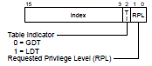
Figure 26. Segment Selector
A segment selector is a 16-bit identifier for a segment (see Figure 3-6). It does not point directly to the segment, but instead points to the segment descriptor that defines the segment. A segment selector contains the following items:
Index (Bits 3 through 15) — Selects one of 8192 descriptors in the GDT or LDT. The processor multiplies the index value by 8 (the number of bytes in a segment descriptor) and adds the result to the base address of the GDT or LDT (from the GDTR or LDTR register, respectively).
TI (table indicator) flag (Bit 2) — Specifies the descriptor table to use: clearing this flag selects the GDT; setting this flag selects the current LDT.
Requested Privilege Level (RPL) (Bits 0 and 1) — Specifies the privilege level of the selector. The privilege level can range from 0 to 3, with 0 being the most privileged level.

6.4.2 Segment Registers
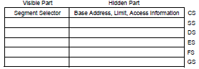
Figure 27. Segment Registers
When a segment selector is loaded into the visible part of a segment register, the processor also loads the hidden part of the segment register with the base address, segment limit, and access control information from the segment descriptor
In systems in which multiple processors have access to the same descriptor tables, it is the responsibility of software to reload the segment registers when the descriptor tables are modified

6.4.3 Segment Descriptors
It is a data structure in a GDT or LDT that provides the processor with the size and location of a segment, as well as access control and status information.
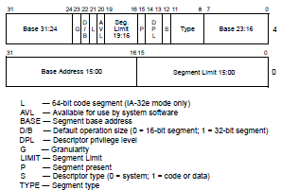
Figure 28. Segment Descriptor

6.4.4 Segment Descriptor Tables
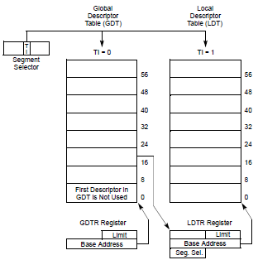
Figure 29. Global and Local Descriptor Tables
2 types- global descriptor table (GDT) and local descriptor tables (LDT)
GDT- which may be used for all programs and tasks in the system
LDT- can be defined for each separate task being run, or some or all tasks can share the same LDT
Global descriptor table (GDT)
- Only one GDT table is provided by the operating system
- GDT table contains segment descriptors for all programs
- Also used by the operating system itself
- Table is initialized during boot up
- GDT table address is stored in the GDTR register
- Modern operating systems (Windows-XP) use one GDT table
Local descriptor table (LDT)
- Another choice is to have a unique LDT table for each program
- LDT table contains segment descriptors for only one program
- LDT table address is stored in the LDTR register
memory management facilities of the IA-32 architecture are divided into two parts: segmentation and paging
Segmentation
provides a mechanism of isolating individual code, data, and stack modules so that multiple programs (or tasks) can run on the same processor without interfering with one another
Paging
provides a mechanism for implementing a conventional demand-paged, virtual-memory system where sections of a program’s execution environment are mapped into physical memory as needed can also be used to provide isolation between multiple tasks

6.4.5 Overview
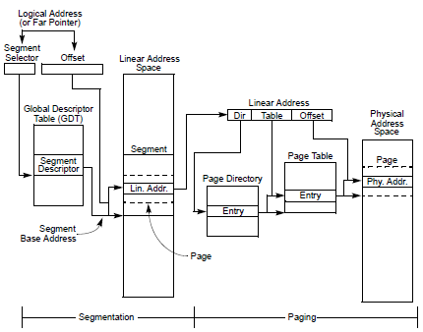
Figure 30. Segmentation and Paging
- processor’s addressable memory space (called the linear address space) is divided into smaller protected address spaces called segments to hold the code, data, and stack for a program or to hold system data structures
- If more than one program (or task) is running on a processor, each program can be assigned its own set of segments.
- Processor ensures that programs don't write on each other’s segments
- A logical address consists of a segment selector (provides base address) and an offset
- The base address plus the offset thus forms a linear address in the processor’s linear address space.
- If paging is not used, the linear address space of the processor is mapped directly into the physical address space of processor.
- Paging supports a “virtual memory” environment where a large linear address space is simulated with a small amount of physical memory (RAM and ROM) and some disk storage
- each segment is divided into pages (typically 4 KBytes each in size), which are stored either in physical memory or on the disk.
- If implemented properly, the swapping of pages between physical memory and the disk is transparent to the correct execution of a program.

